Sandbox: tpx8pro

Step 1: Add the value ‘Outreach’ to ‘Lead Status’ above ‘Spam’.

Step 2: Verify that these users are active

* Mohler Alex
* Welch Brittany
* Walters Stephanie
* Tabor Kyle
* Magyar Paul

Step 3: Install these apps

* <https://appexchange.salesforce.com/appxListingDetail?listingId=a0N3A00000ErHZ4UAN>
* <https://appexchange.salesforce.com/appxListingDetail?listingId=a0N3A00000EJc1NUAT>

Step 4: Active Enable ExperienceBundle Metadata API in Community Settings and create a Community called ELLEN World with the template Customer Account Portal.

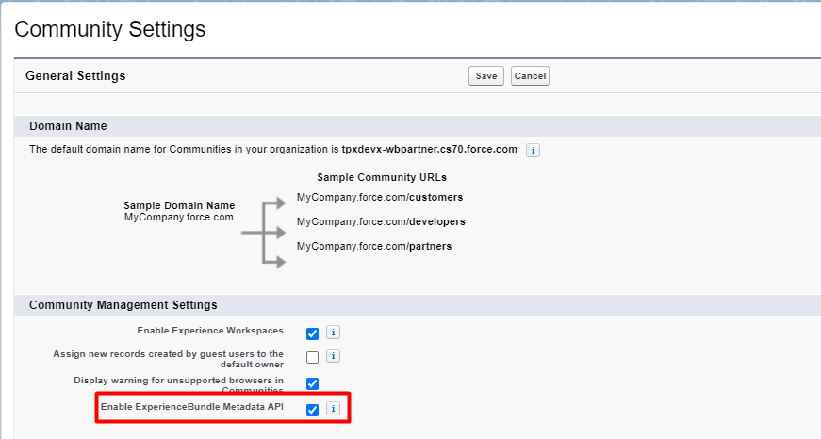

* Create Navigations in the community.

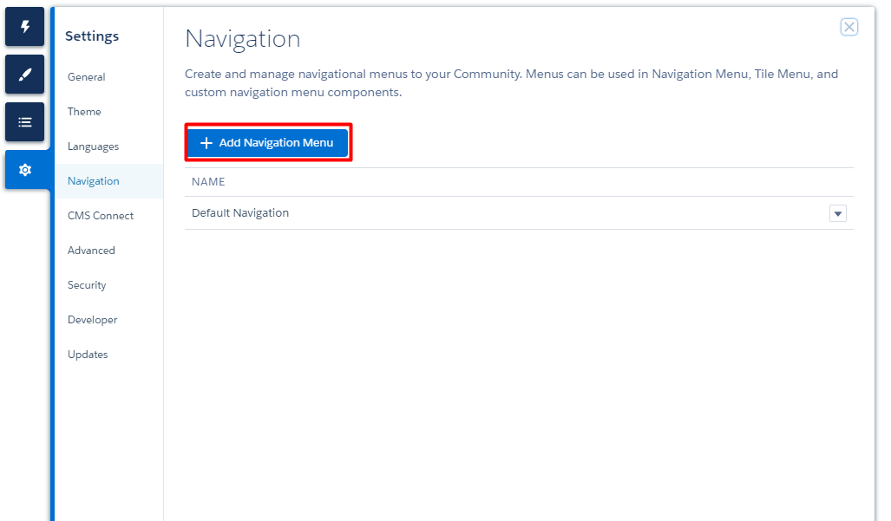

* + CaseStudy
  + DIGITAL Ellentube Series
  + Digital Navigation
  + Ellen’s Game of Games
  + ELLEN STAFFERS
  + ellentube series 2
  + KID TALENT
  + Mobil Games
  + ON-Air
  + ON-AIR_Tentpole_Episode
  + ON-AIR_Trade_out
  + TALENT
  + TALENT2

Step 5: Retrieve and deploy Asset_1.xml

Step 6: Retrieve and deploy Asset_2.xml

Step 7: Retrieve and deploy Asset_3.xml

Step 8: Retrieve and deploy Asset_4.xml

Step 9: Retrieve and deploy Asset_5.xml

Step 10: Retrieve package objets and configuration.xml

* Unzip file, and replace community_navigation:tileMenu with forceCommunity:tileMenu in all files in /experience/views/.

Leave only the tileMenuEditor attribute 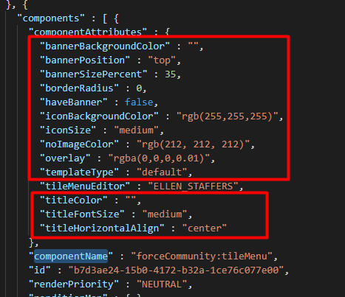

example

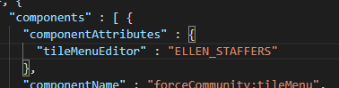

* Count the communities starting from zero and take the number that corresponds to the community of ellen, in this example their number would be 4

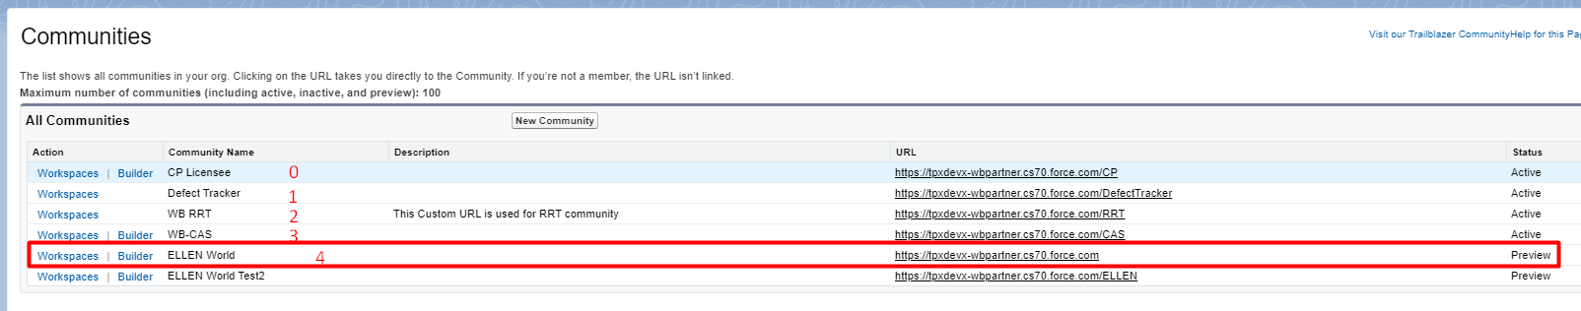

* Search Default_Navigation in /experiences/Ellen_World1/theme/ customerAccountPortal.json and replace the number at the end with the one obtained in the previous point. in this case it must be Default_Navigation4

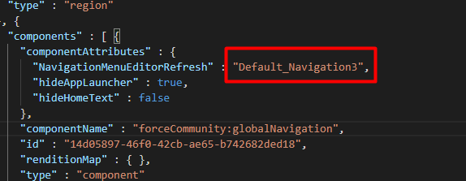

In my case it worked with 5, Apparently it is by order of creation

* Zip the folder and deploy, Run Test: Create_lead_Community_Controller_Test,CustomVideoGalleryTest

I ran into the following error:

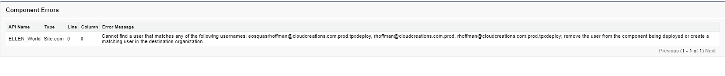

I fixed it by replacing the username field of the user Rachelle Hoffman:

rhoffman@cloudcreations.com.tpxdeploy -> rhoffman@cloudcreations.com.prod.tpxdeploy

Step 11: Retrieve NavigationMenus.xml and unzip

* Go package.xml and Replace the number at the end as the previous Step, in this case Default_Navigation3 with Default_Navigation4.
* Rename the file /navigationsMenus/Default_Navigation3.navigationMenu following the previous structure.